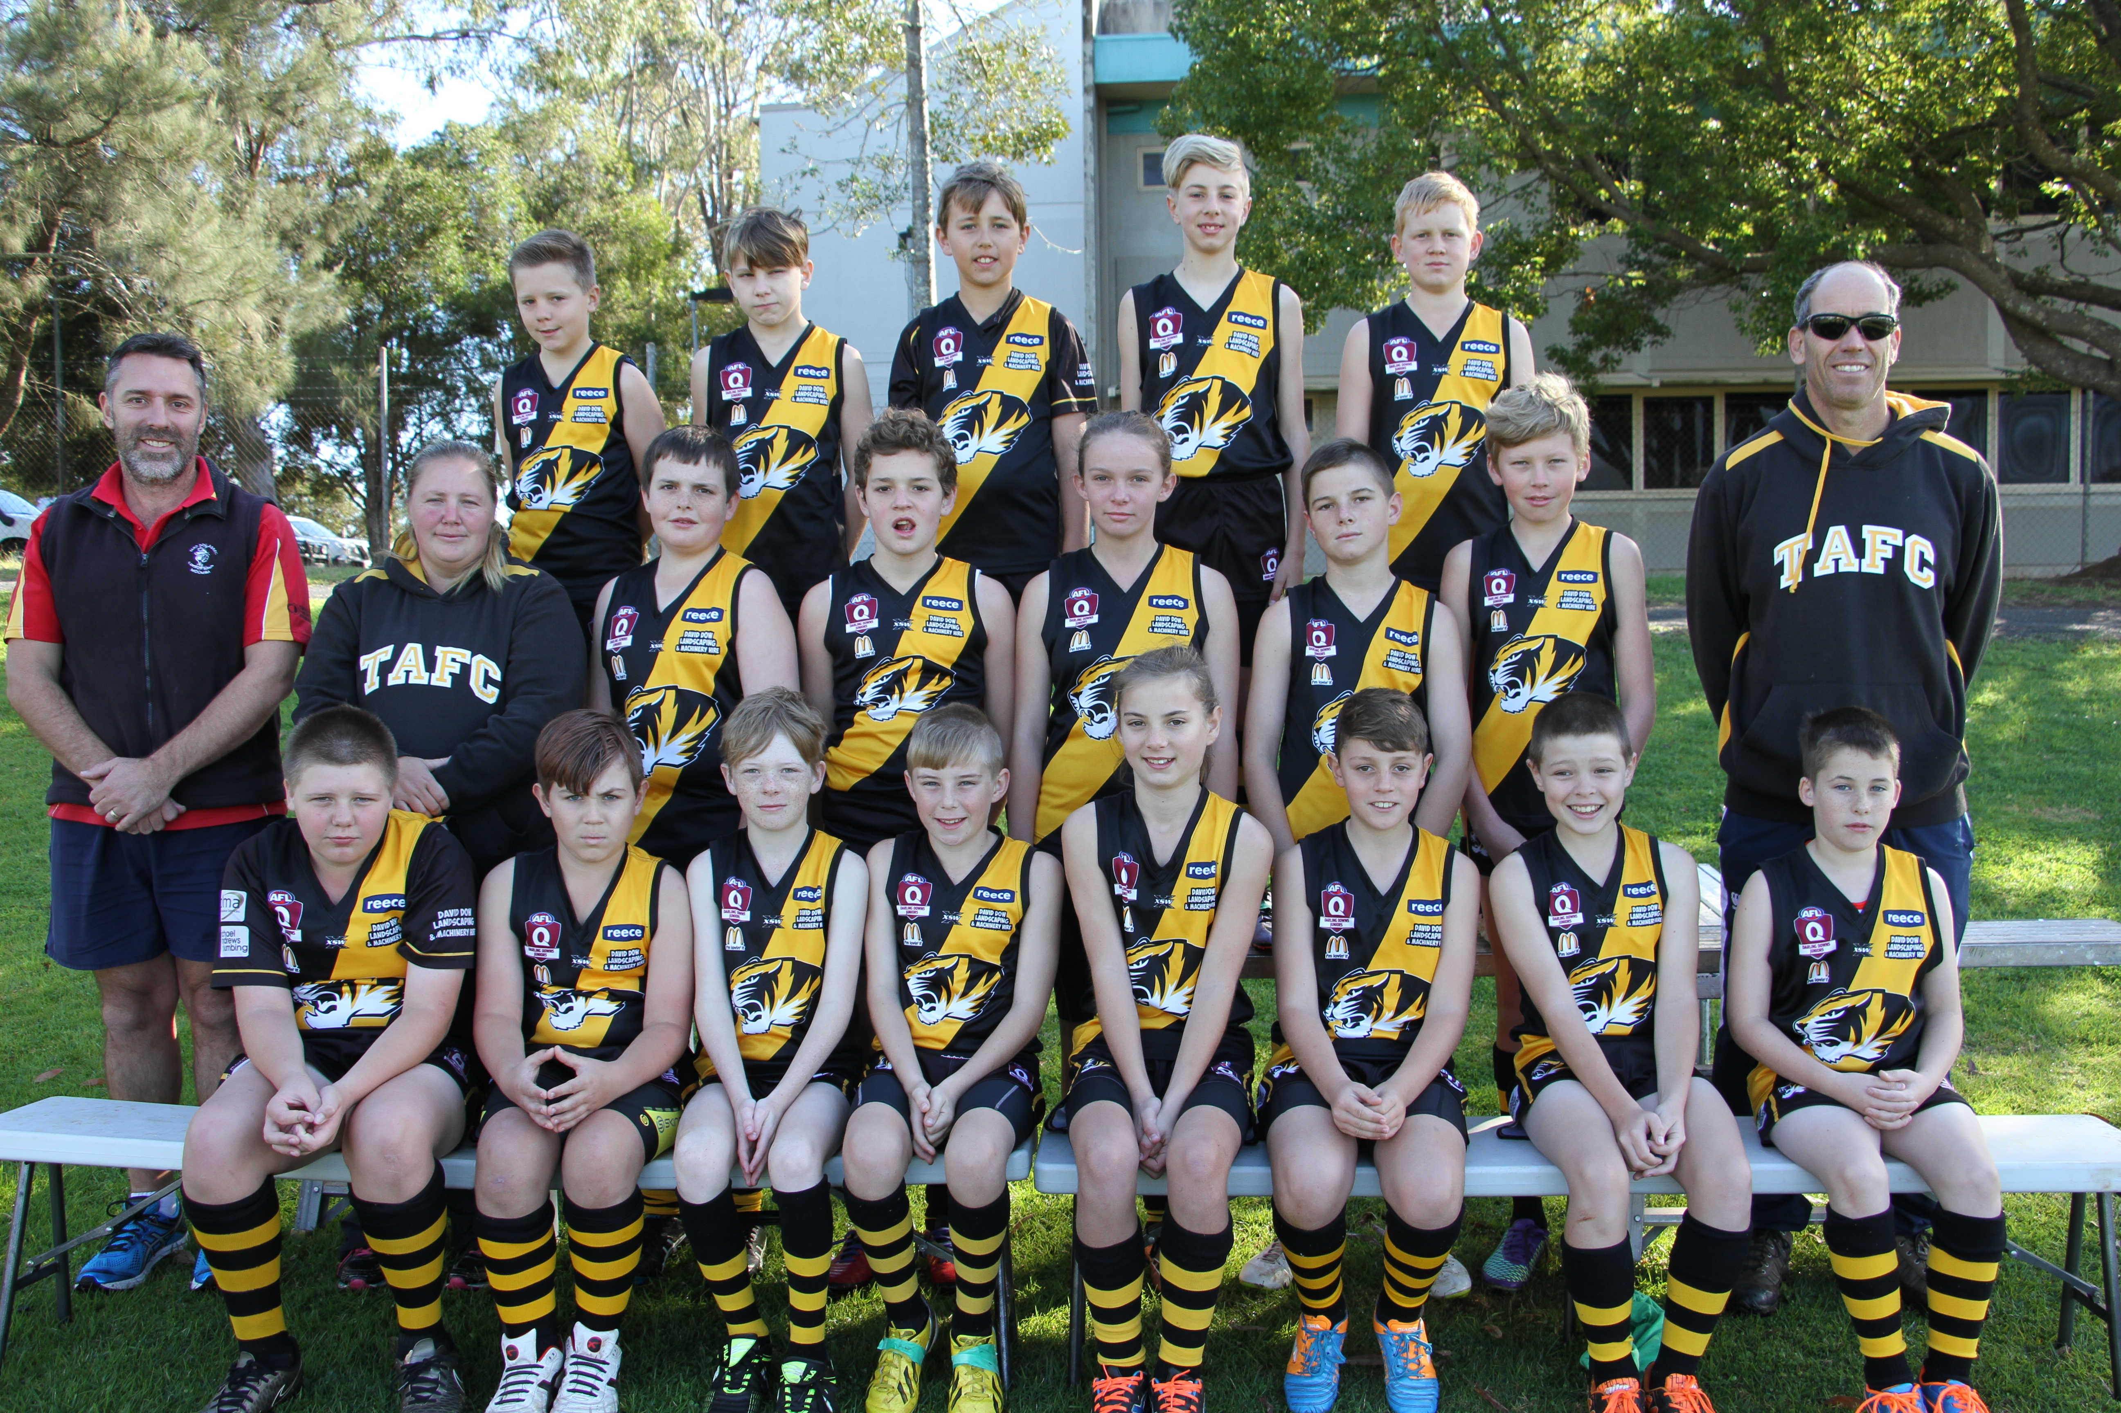




Back row L to R Jerome Jooste, Tay Blower, Jack Becker, Samuel Holt, Patrick Dolbel
Middle row L to R Craig Scutchings (Sports Trainer) Tabitha Steinberg (Manager) Joshua Sylvester, Samuel Elliott, Charlotte Collins, Philip Grutt,
Connor Larsen , Paul Herbert ( Coach)
Front row L to R Ricki Steinberg , Lincoln Wischnat , Clayton Taylor, Matthew Holt, Lara Paget, Harley Scutchings, Joshua Challis, Terence Hind
Absent Lawson Herbert , Isaac Leeding

