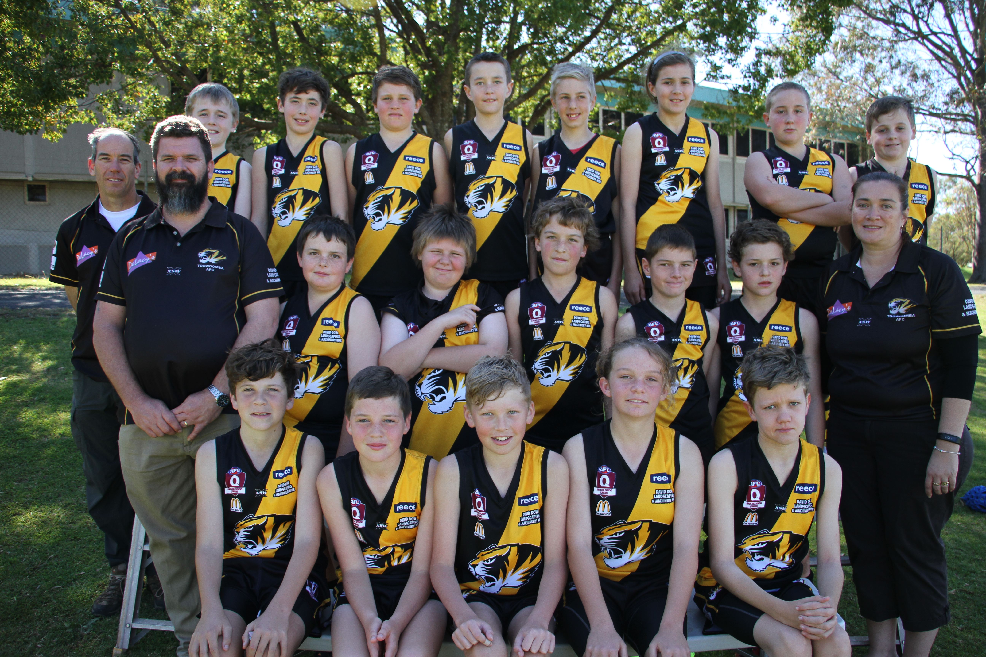




Back Row (L-R) : Paul Herbert (Coach)Jacob Payne, Bailey Ciurleo, William Makejev, Kieran Donoghue, Samuel Holt, Rachael Burns,
Noah Shepherdson, William Sullivan
Middle Row L-R : Nathan Burns (Assistant Coach) Joshua Sylvester, Ricki Steinberg, Lawson Herbert, Phillip Donaldson,
Samuel Elliott, Nicole Burns (Manager)
Front Row L-R: Lachlan Sheldrick, Gabe Stower, Connor Larsen, Charlotte Collins, Mark Guthrie

