


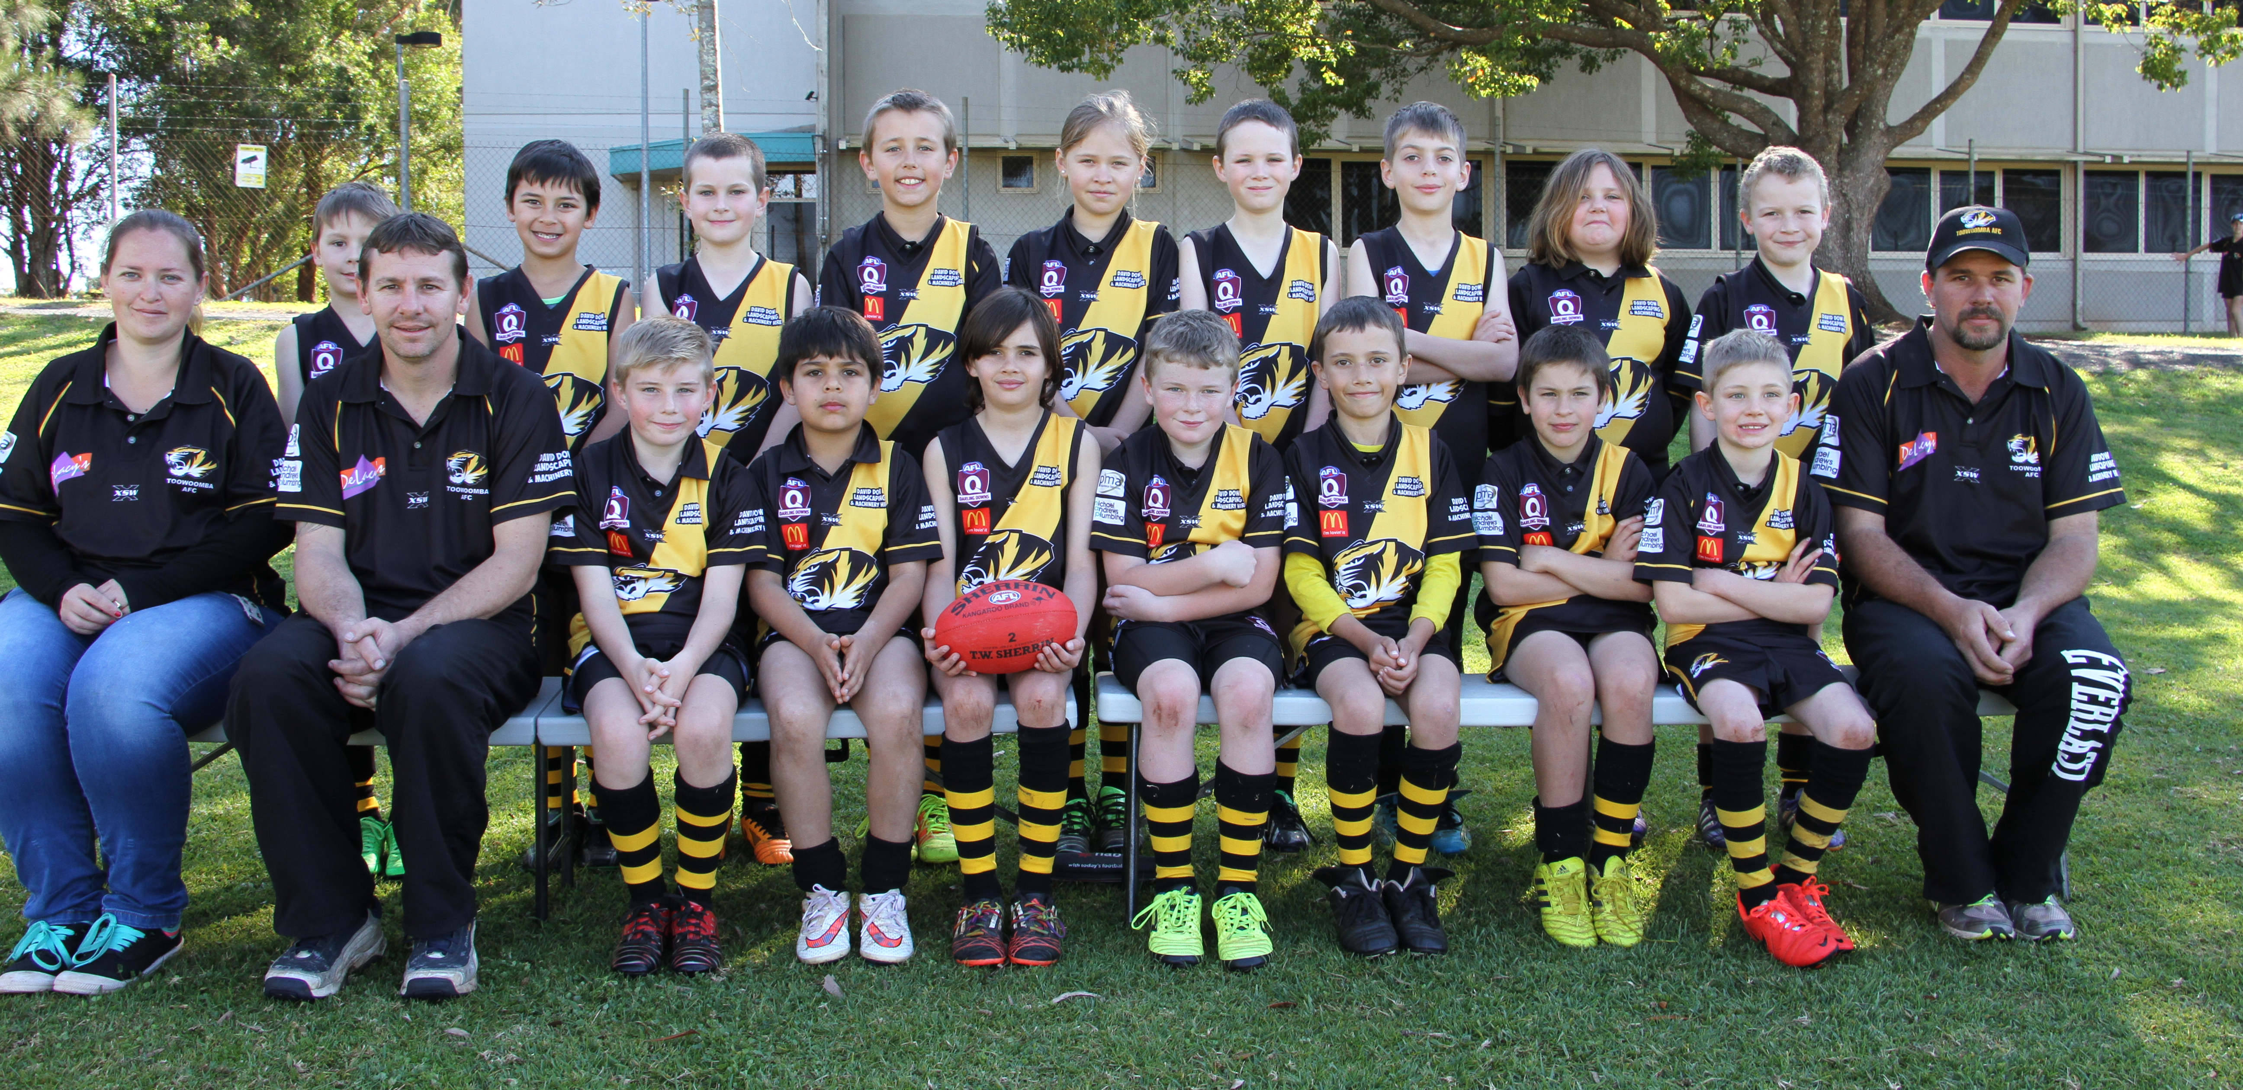

Back row (L to R) Billy Retallick, Jack Scott, Joss Ronan, Jack Becker, Mia Larsen, Owen Harper, David Bell, Amber Steinberg, Jonte Sheldrick
Front Row (L to R) Vanessa Chappell (Manager), Calvin Retallick (Co-coach), Matt Holt, William Humes, Lachlan Cosgriff, Zac Turner, Harley Chappell,
Cooper Erdmann, Eli Turner, Nathan Chappell (Co-coach)

