


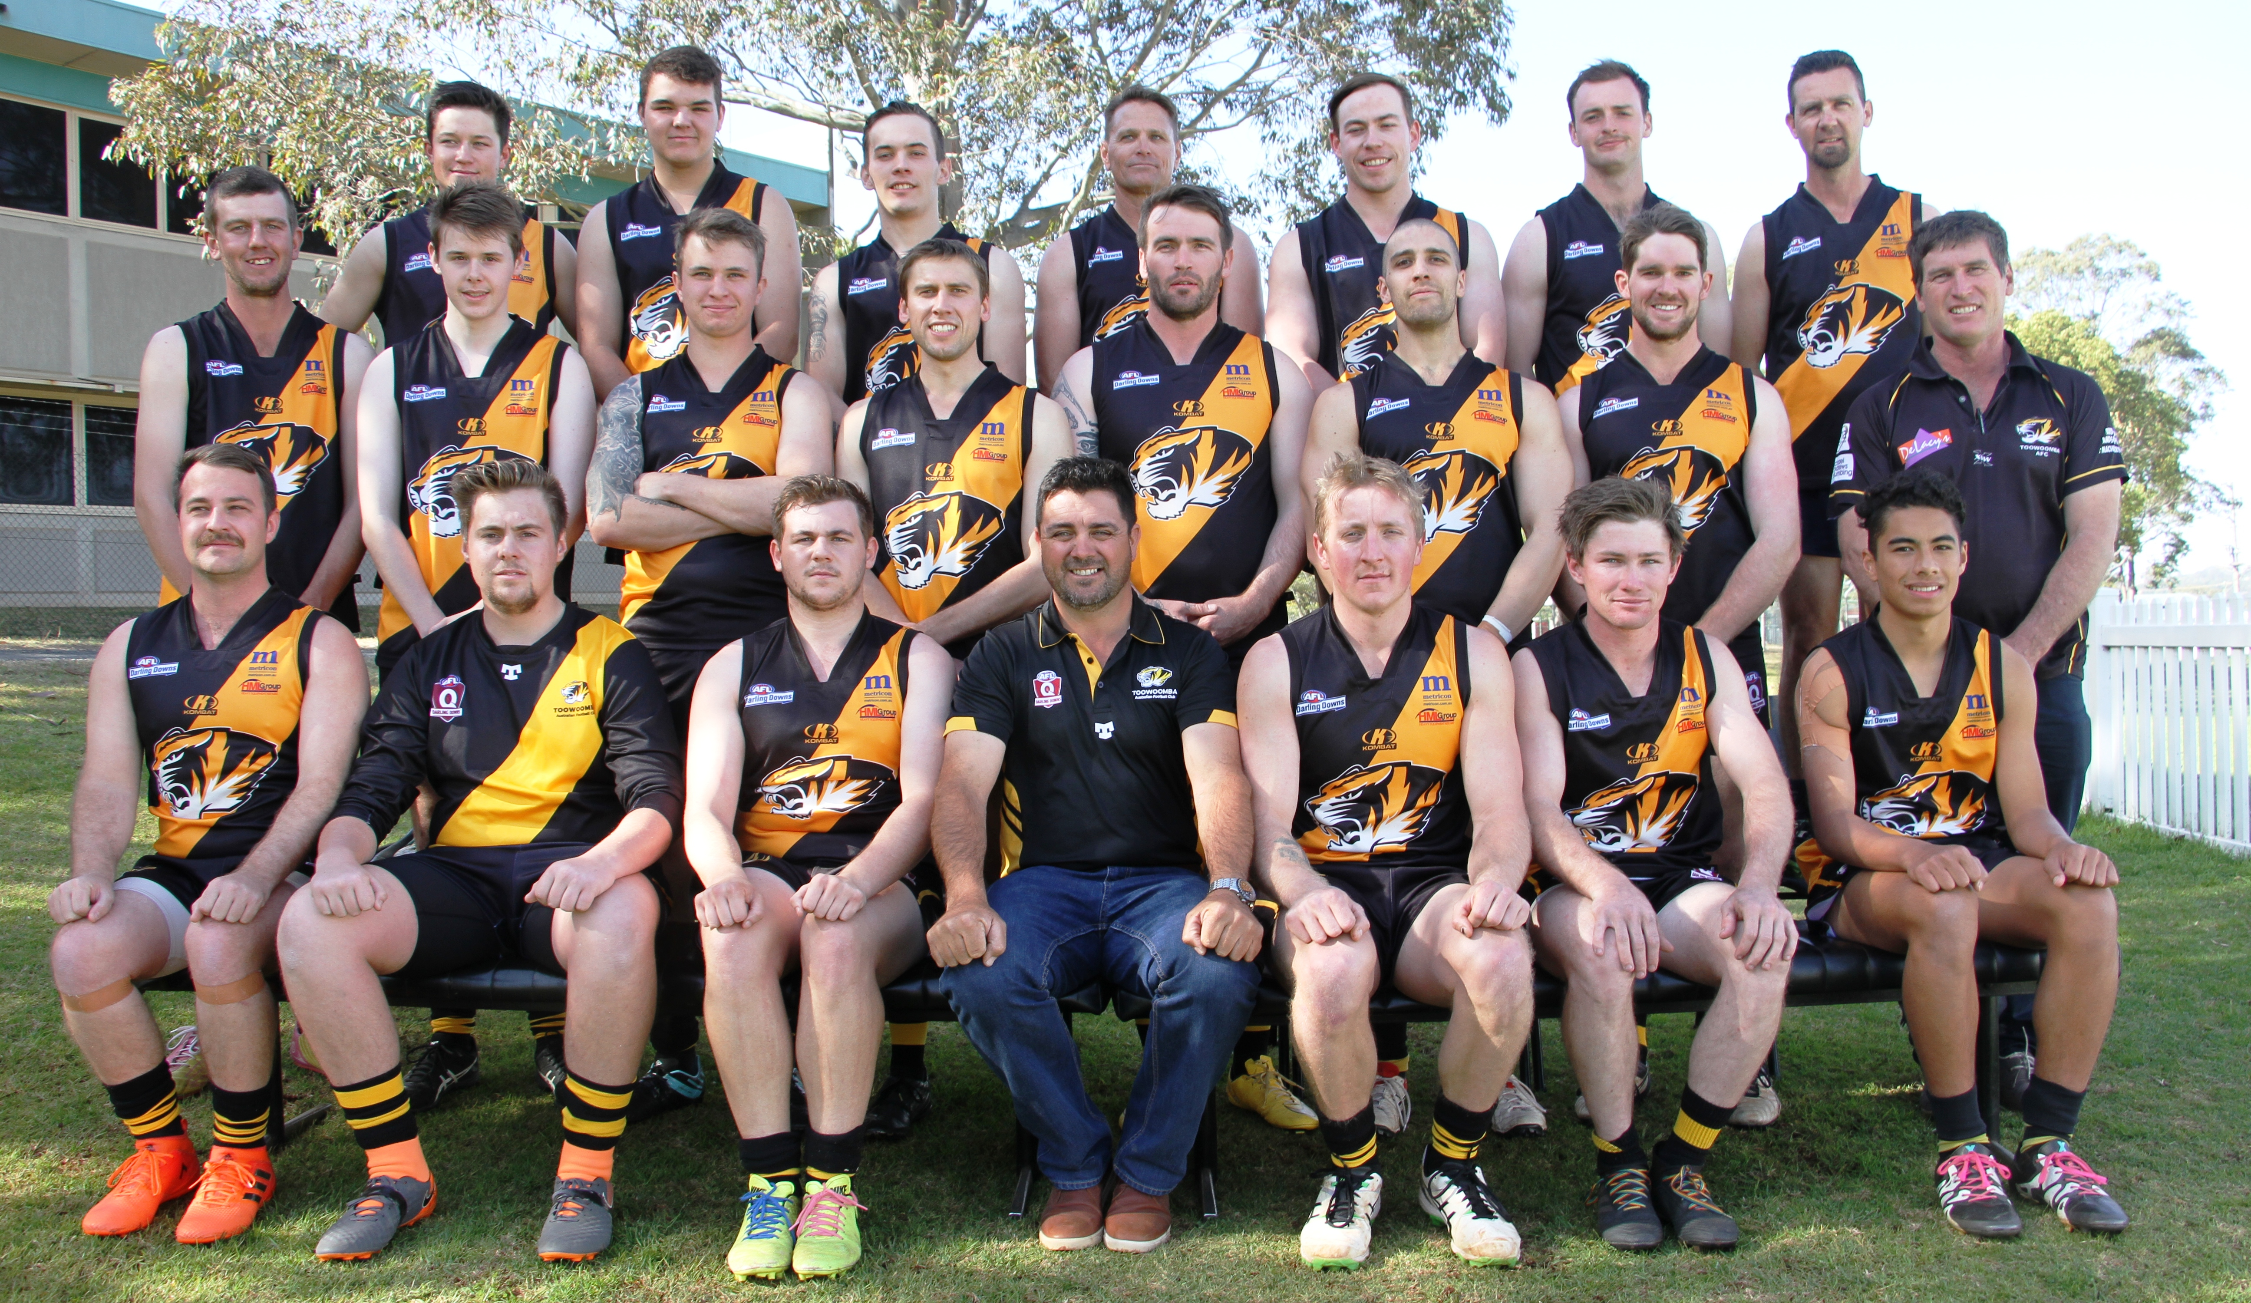

Back Row (L-R) : Jacob Agius, Matthew Moore, Liam Ward, Geoffrey Smith, Scott Reaper, Nathan Shields, Leyton Webb
Middle Row (L-R) : Robert Butters, Luke Saffron, Brad Blackburn, Jonathan Handreck, Aaron Passmore, Stephen Harbort,
Michael Bailey, Richard Baker (Manager)
Front Row (L-R ): Blair Hinds, Luke Galley, Jacob Lawson, Scott Hannon (Coach), Christopher Turpin, Jayden Smith, Anthony Wolbers
Absent: Alexander Taylor, Brett Killury, Daniel McErvale, Cameron Percival, Felix Taylor, Jacob Martens, Jeremy Haaksma,
Luke Pickup, Matthew Gallagher, Michael O’Donoghue, Thomas Dolan, Trent Ballin, William MacDonald, Zachari Prince.

