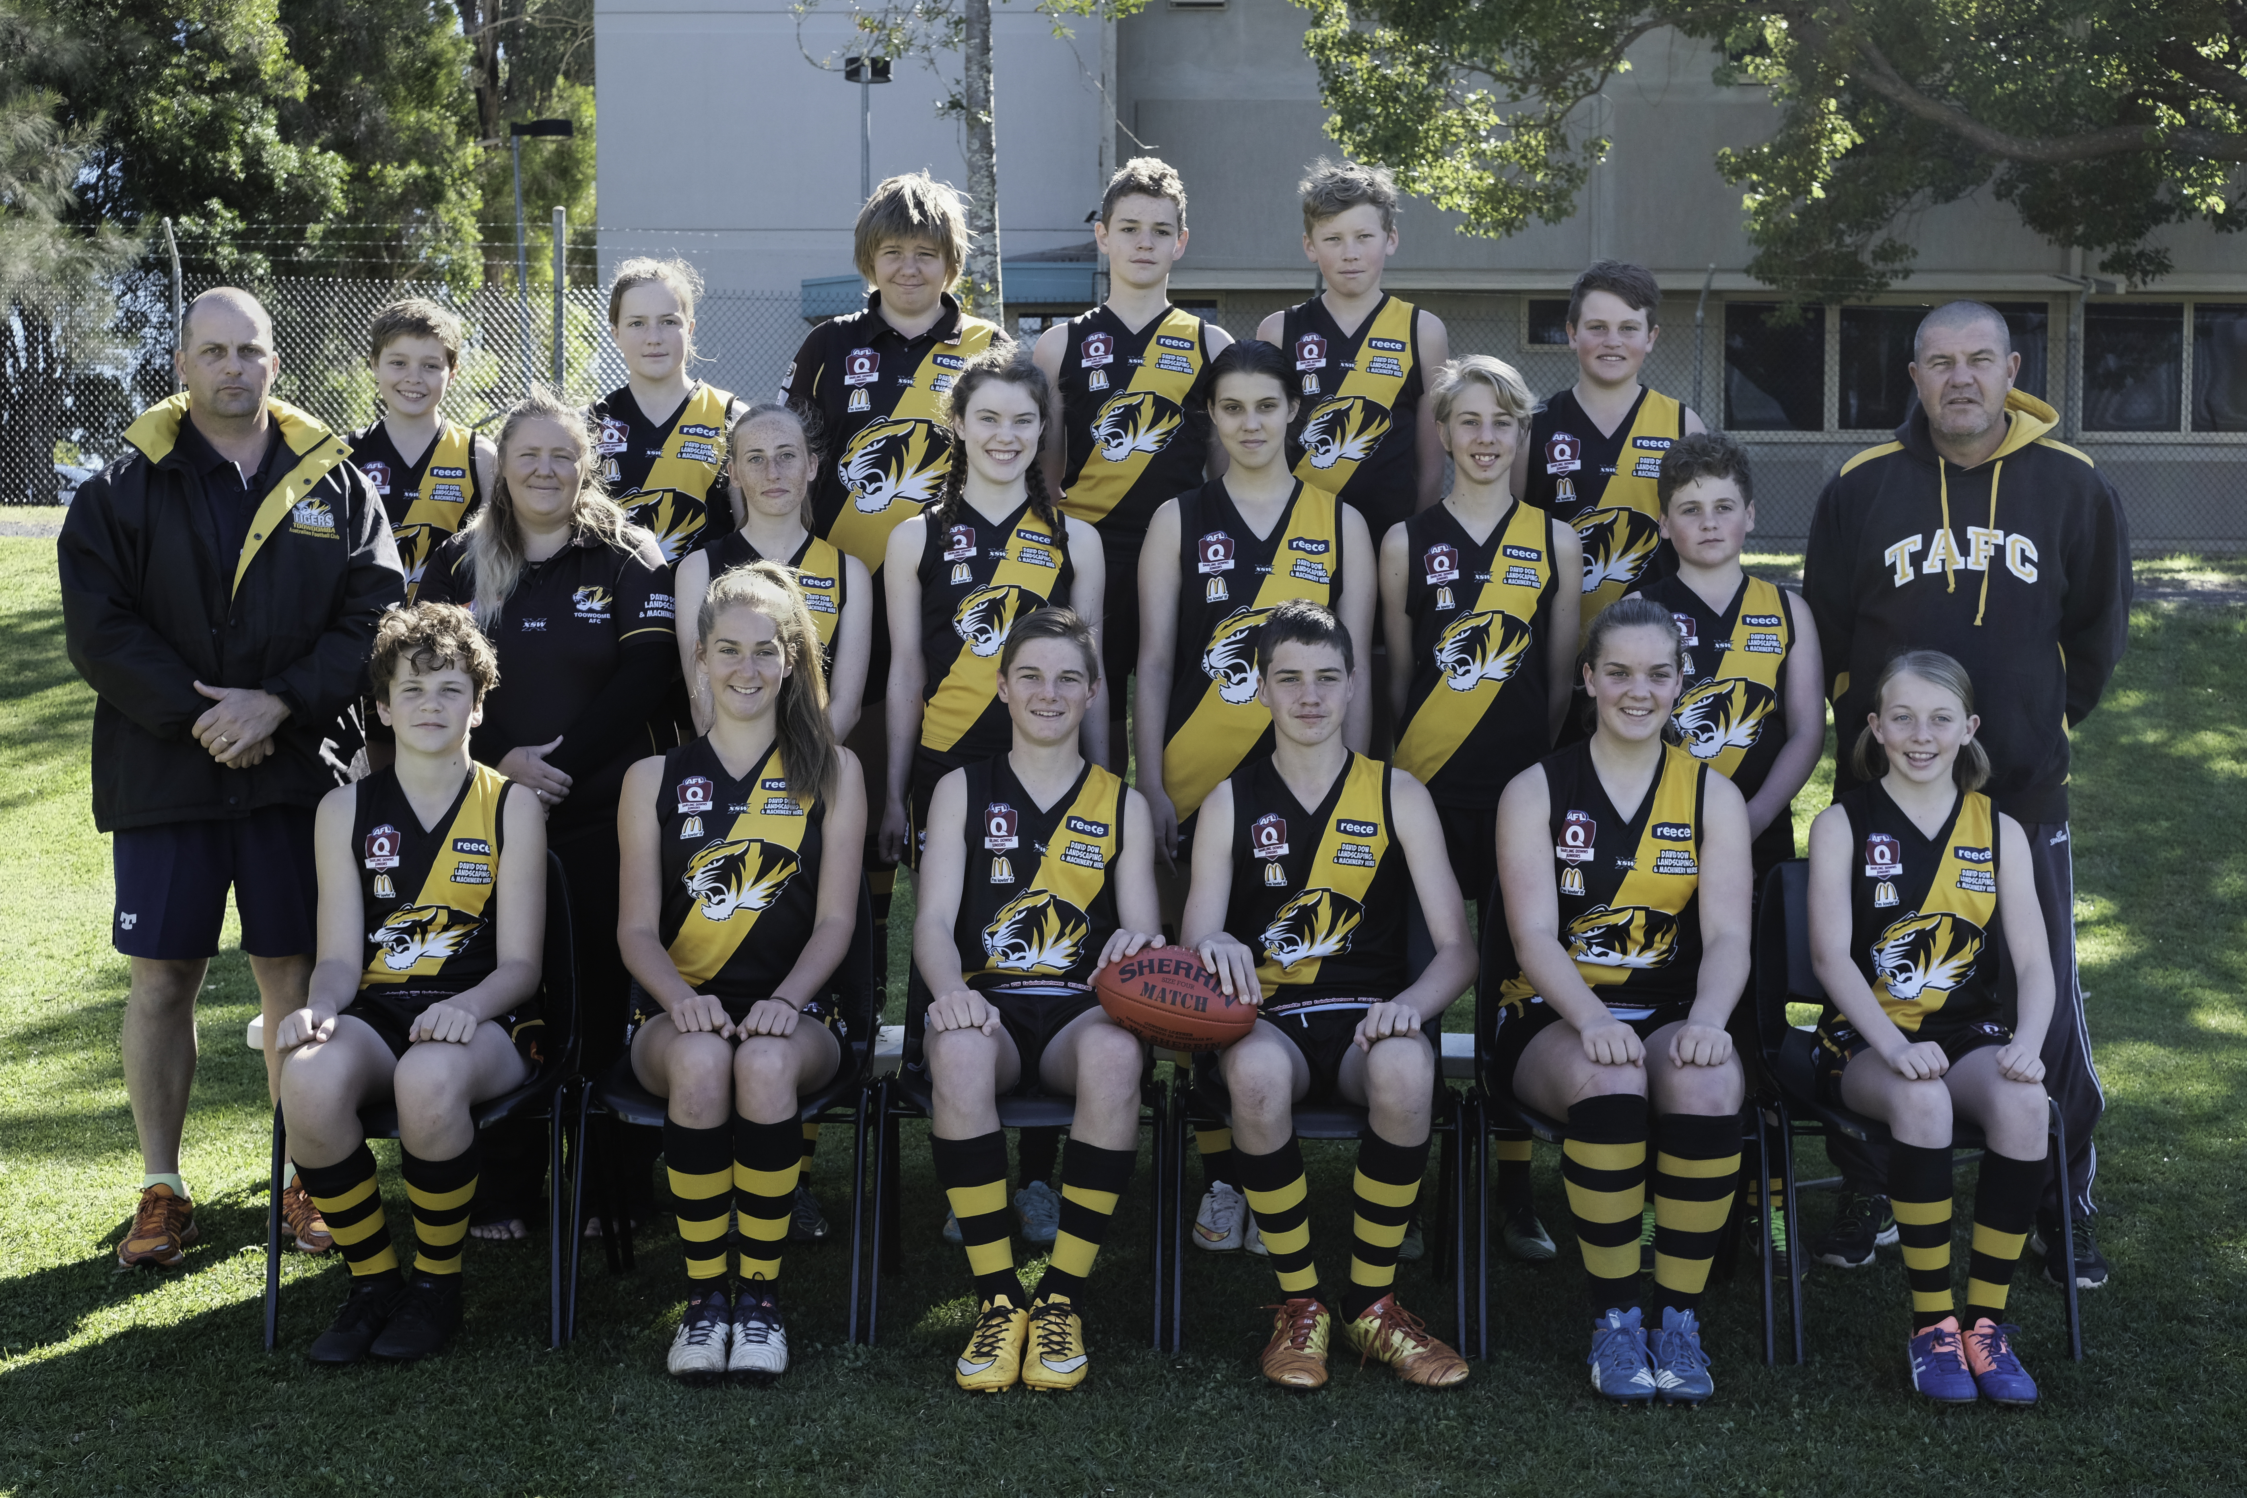




Back row L-R: Joshua Challis, Sierra Hollis, Ricki Steinberg, Samuel Elliott, Connor Larsen, William Makejev
Middle row L-R: Dan Fraser (coach), Tabitha Steinberg (manager), Shania Bell, Lucy O’Connor, Georgina Muller, Samuel Holt, William Sullivan, Peter Stower (coach)
Front row L-R: Lachlan Sheldrick , Tiarna Jericho , Phillip Grutt, Gabe Stower, Molly Fraser, Miranda Broadfoot

Absent: Paul Herbert (coach), Lawson Herbert, Charlotte Collins, Bailey Ciurleo

