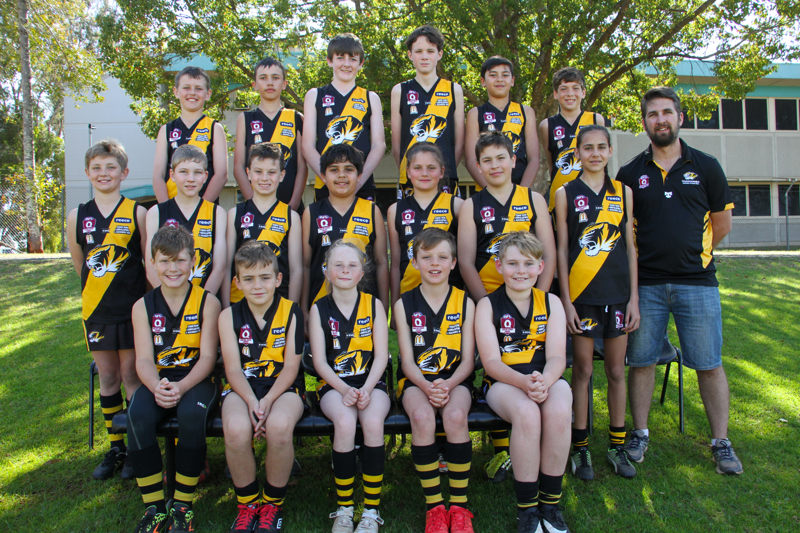

Back row L to R Riley Becker, Harley Chappell, Byron Colley, Owen Harper, Jack Scott, Jacob Bell
Middle row L to R Eli Turner, Aaron Convery, Jack Adamson, William Humes, Kathryn Elliot, Cooper Erdmann, Rhianna Webb, Matthew Harbort (Coach)
Front row L to R Jackson Stewart, Zaiden Smith, Aleisha Bell, Will Anderson, Ethan Power
Absent Elijah Miller, Will Turner, Mason Taylor, Ben Steinberg

