


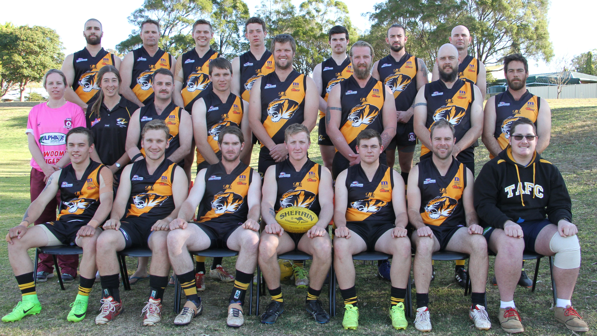

Back Row (L-R) : Stephen Harbort, Geoffrey Smith, Jake Alexander, Billy McDonald, Cameron Doherty, Matthew Gallagher, Chad Harper
Middle Row (L-R) : Nikita Siebuhr (Sports Trainer), Lauren Jericho (Manager), Blair Hinds, Jeremy Haaksma, Trent Ballin, Dan Stapleton,
Mark Menhinnit, Luke Hall
Front Row (L-R ): Liam Ward, Alexander Taylor, Michael Bailey (Captain), Chris Turpin ( Coach), Jake Lawson, Michael O'Donoghue, Josh Mengel
Absent: Ethan Buckwell, Brodie Carlsson, Daniel McErvale, Cameron Percival, Craig Flowers, Daniel Smith, George Leigh,
Jack Sloan, Jacob Martens, Jonah Stower, Joseph Kelly, Luke Adams, Matt Brown, Matthew Taylor, Michael Rae,
Josh Paul, Sean Clark, Trent Tiller, Sam Taylor

