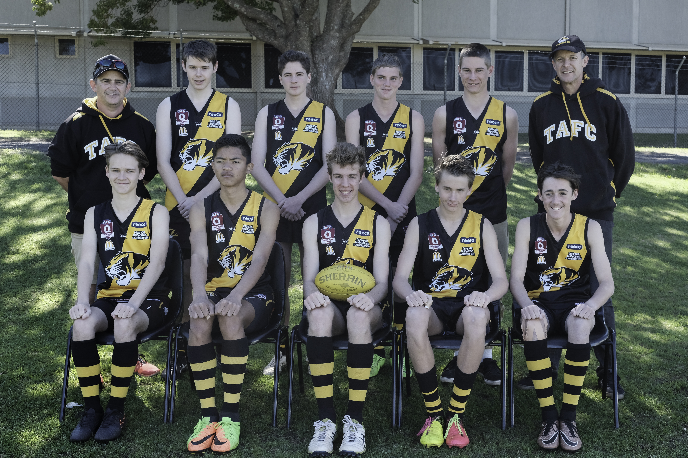



BACK ROW L/R : Peter Smoothey (Manager), Luke Saffron, Campbell Francisco, Toby Milburn, Chris Grutt, Jeremy Sheldrick (Coach)
FRONT ROW L/R : Harrison Pugh, Thewan Namwat, Jacob Holt, Jack Briskey, Corey Smoothey
ABSENT : Jack Sheldrick

