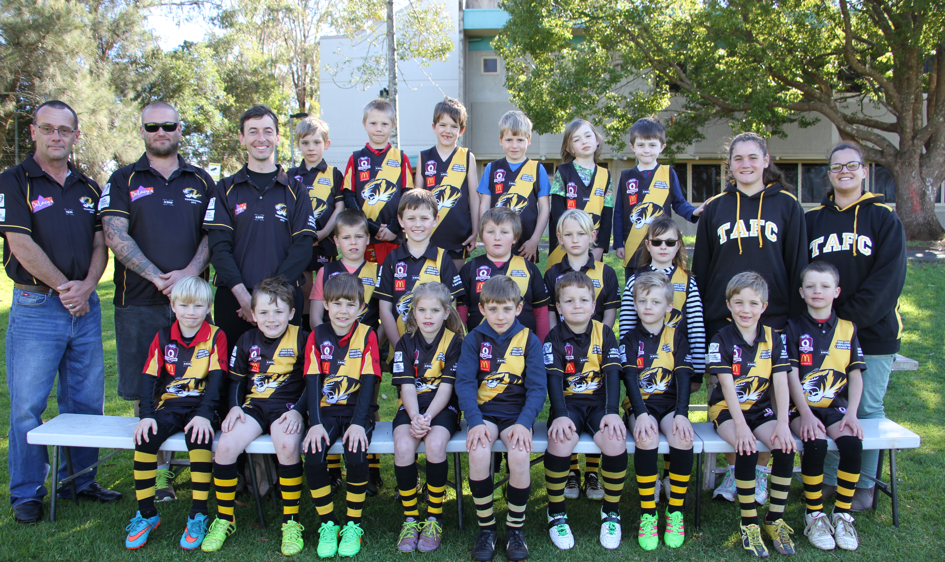




Back Row L – R : Cairo Turner, Tjay Blower, Lachlan McErvale, Izak Bryce, Hannah Willett, Michael Willett.
Middle Row L-R: Steve Lawrence (Manager), Sean Clark (Manager), Andrew Bell (Coach), Kurt Bryce, Riley Becker, Ben Steinberg, Jackson Clark, Sarah Sylvester, Grace Elliott (Assistant Coach), Jes Lawrence (Manager).
Front Row L-R: Quinton Blower, Elijah Miller, Ryly Blower, Charli Chappell, William Turner, Lael Lawrence, Noah Miller,
Flynn Turner, Will Anderson
Absent : Alexis Walsh-Scott

