2020 - Under 12.5s
TOOWOOMBA AUSTRALIAN FOOTBALL CLUB
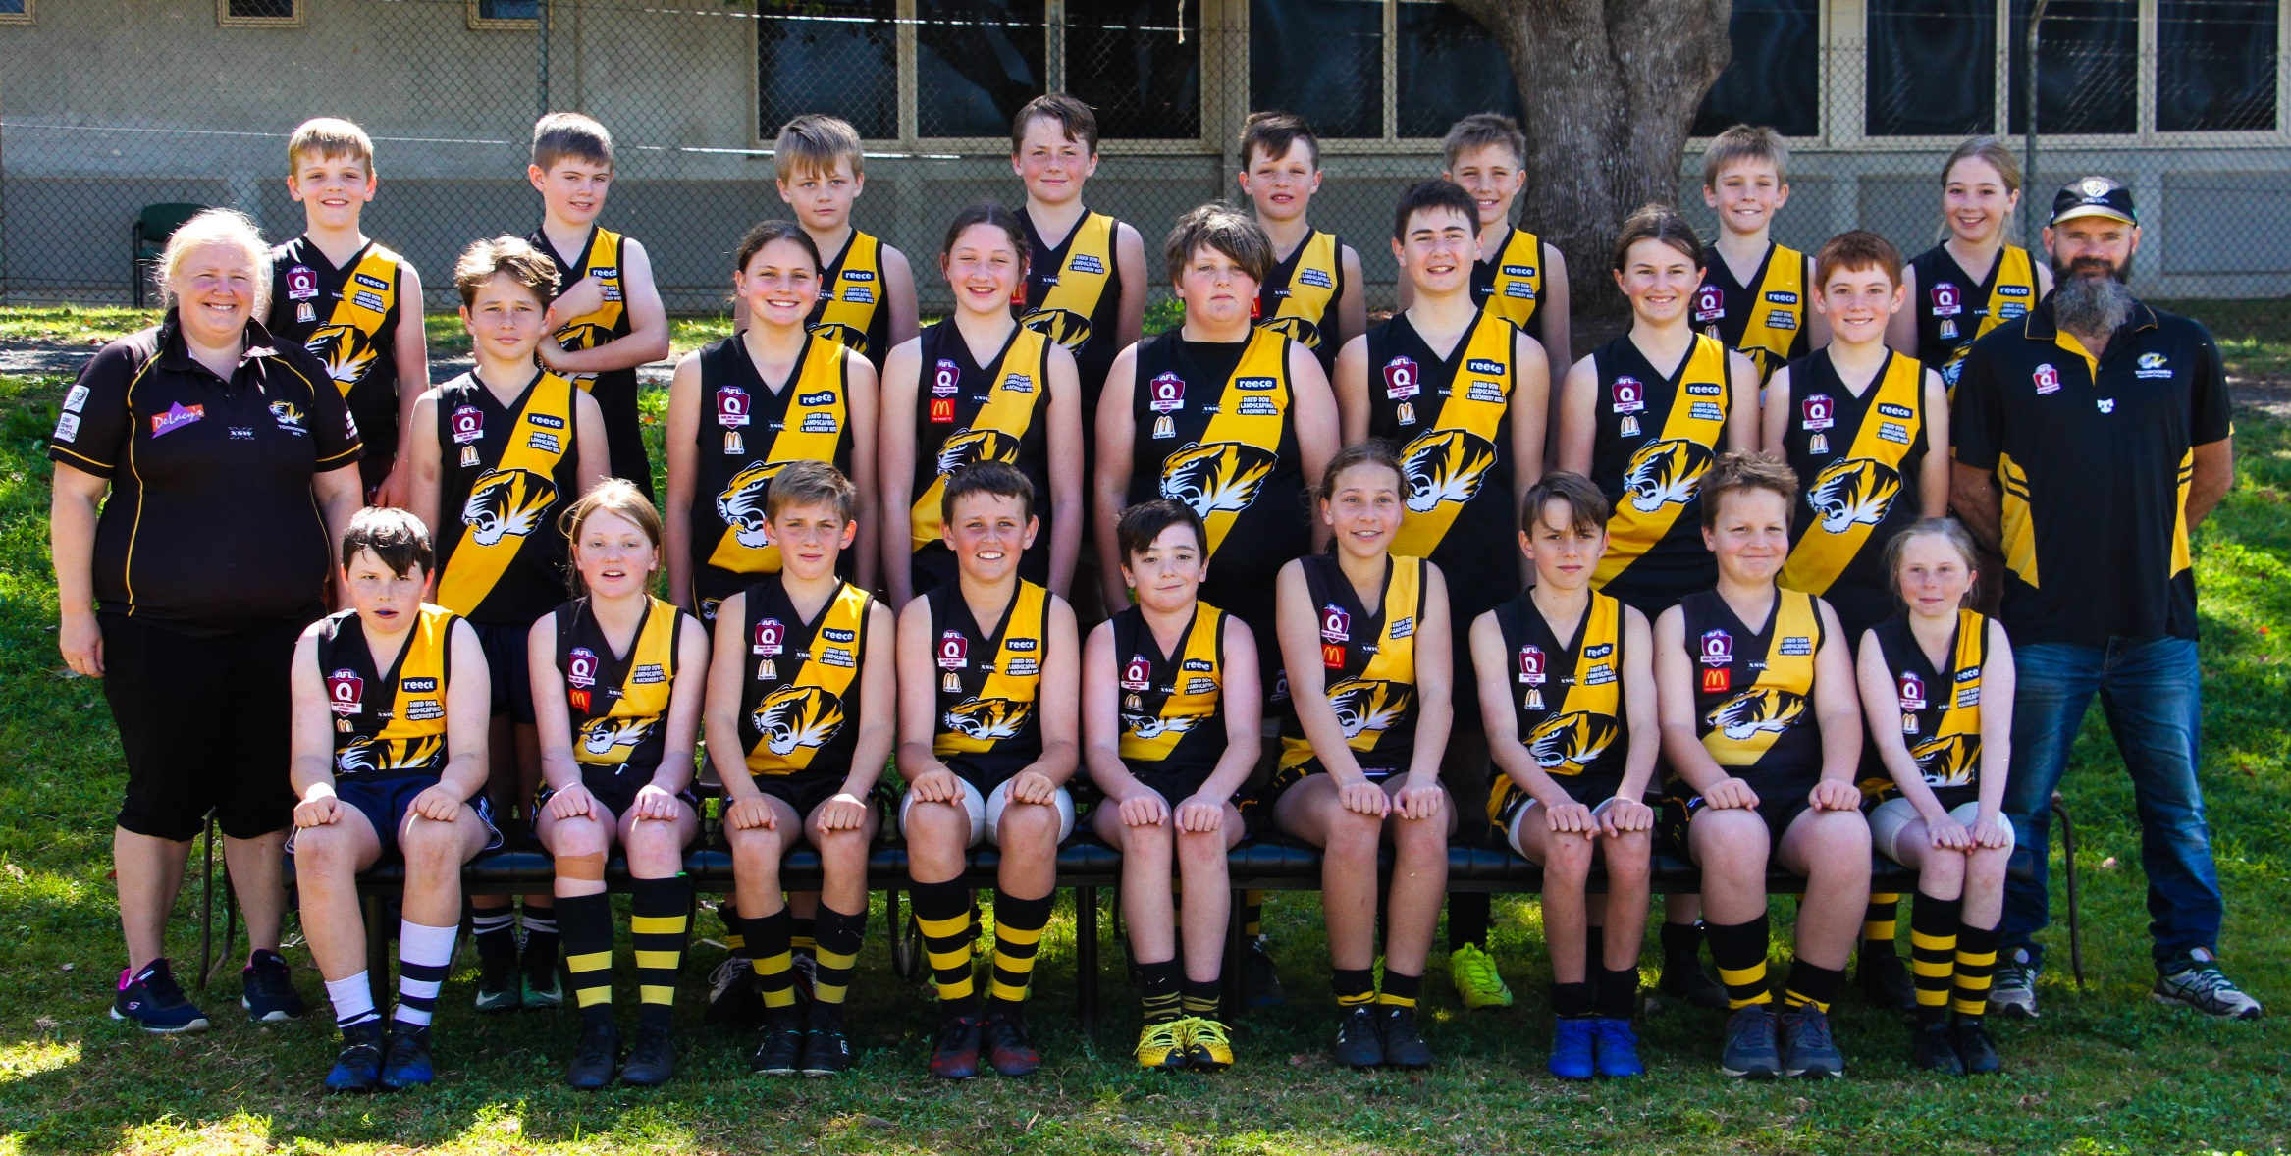

Back row L to R Angus Fraser, Rohan Gaffney, Noah Miller, Elijah Miller, William Anderson, Flynn Turner, Cairo Turner, Taylor Diprose.
Middle row L to R Tabitha Steinberg (Team Manager), William Paynter, Kathryn Elliott, Kalea Anderson, Ben Steinberg, Mikael Artavilla'Bennett,
Penelope Bruce, Sean Gaffney, Cameron Diprose (Coach)
Front row L to R Preston Kelly, Abby Sykes, William Turner, Riley Becker, Aiden Diprose, Sienna Wilson, Luca Paget, Lael Lawrence, Aleisha Bell.

