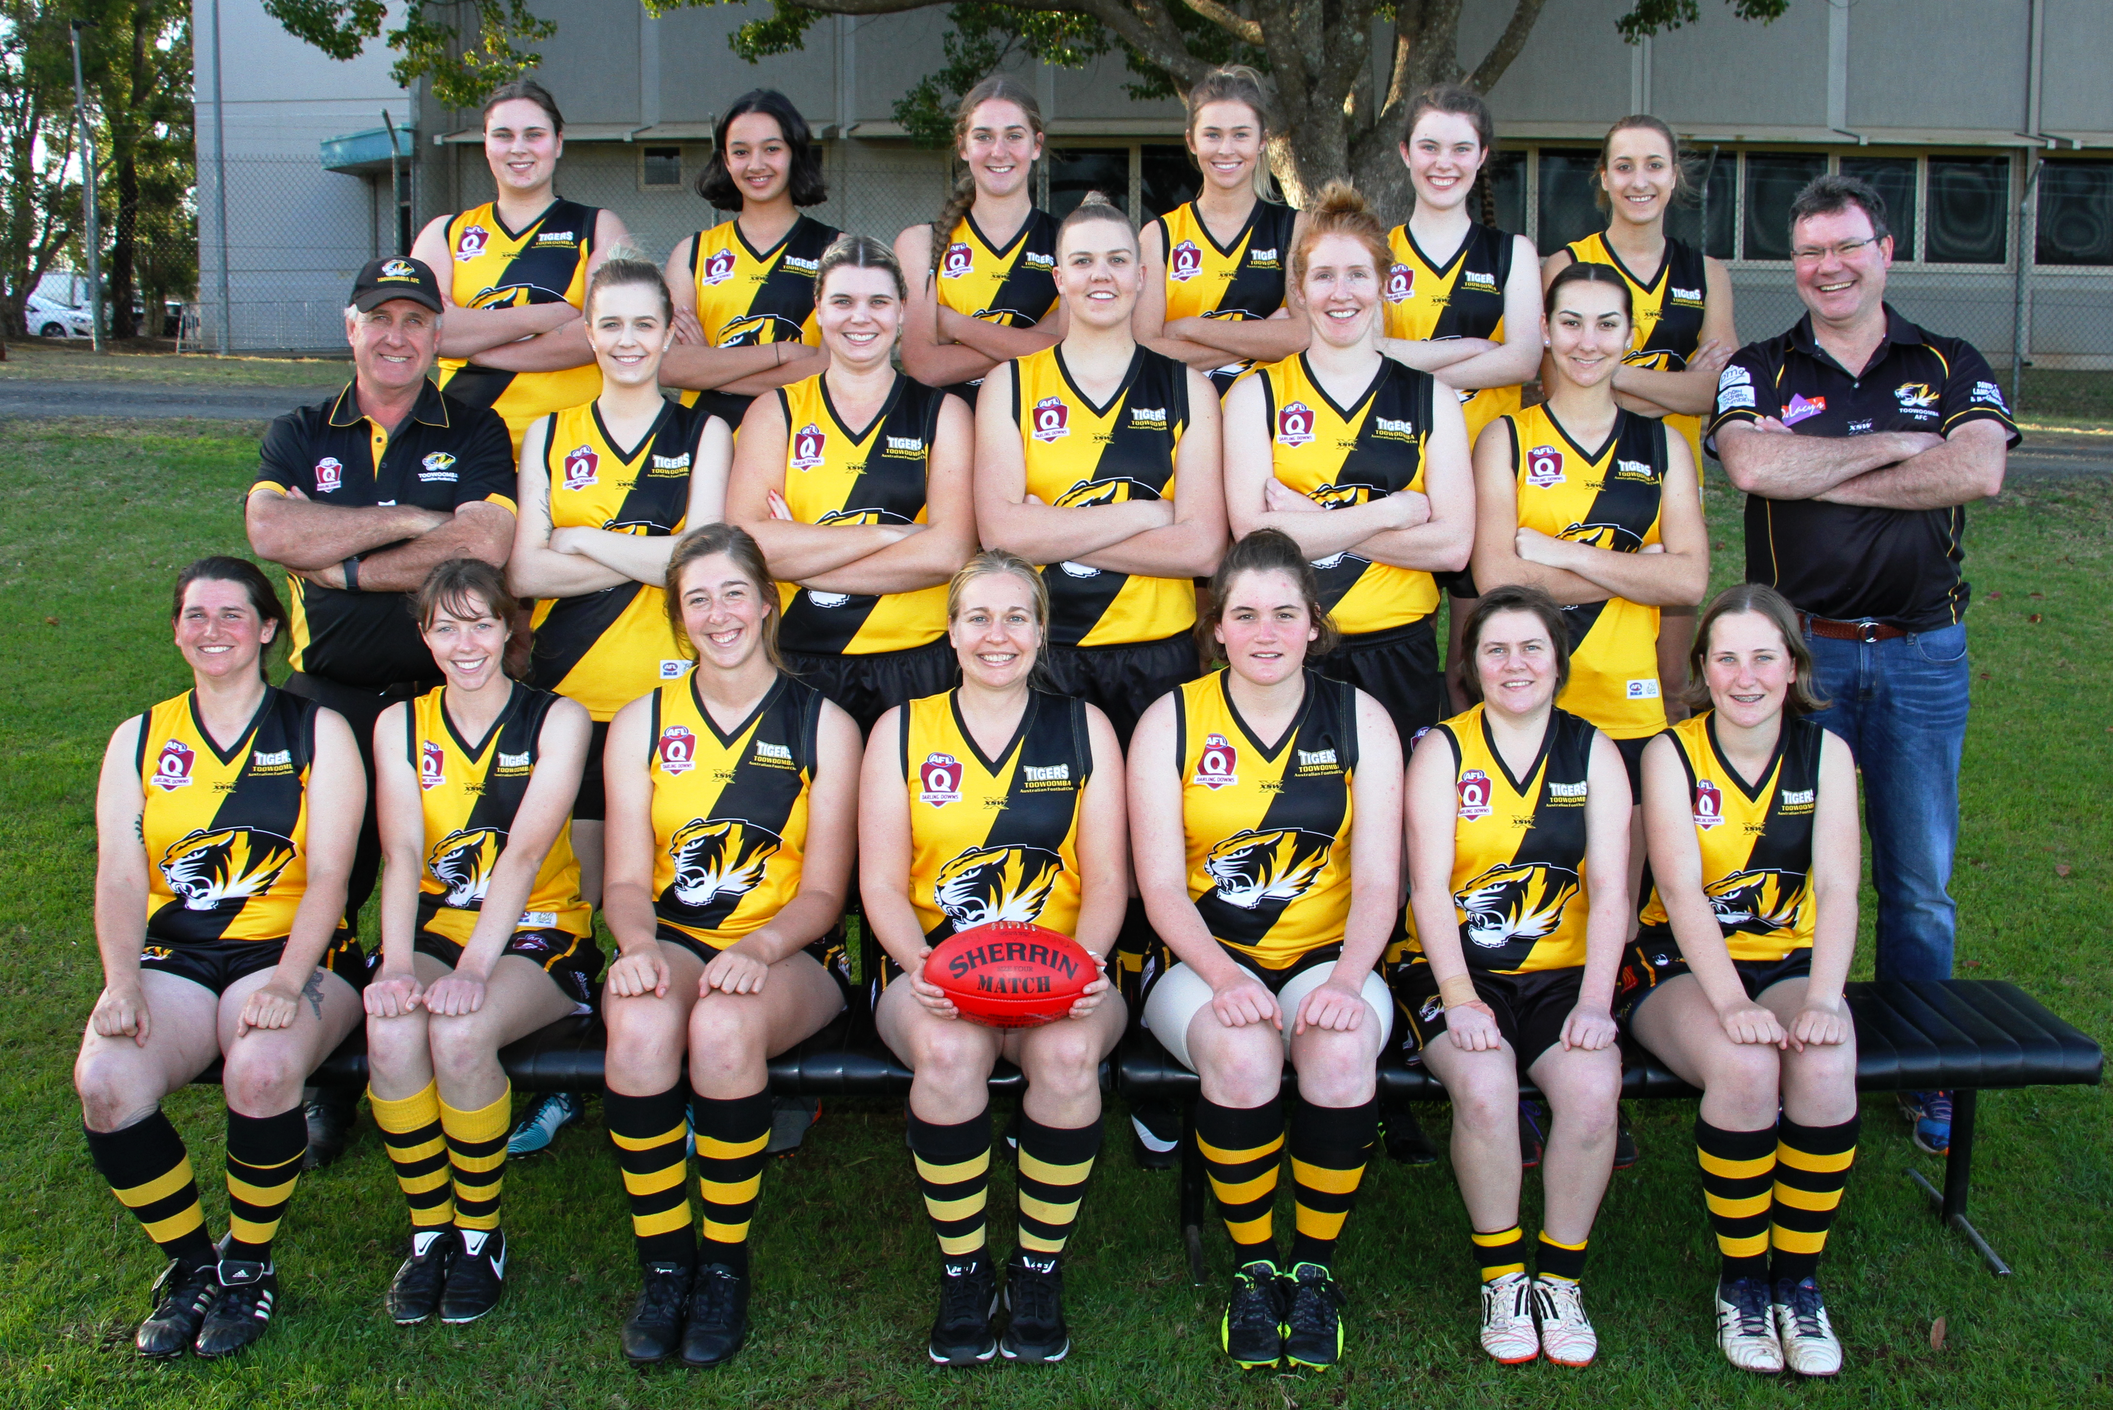



Back Row (L-R) : Madison Crook, Madeline Saunders, Tiarna Jericho, Jemma Whitney, Lucy O'Connor, Carlee Mesken
Middle Row (L-R) : Neville Jericho (Coach), Courtney Lange, Vanessa Weber, Elise Craig, Brigette Fee, Grace Bloomfield, Patrick O'Connor (Manager)
Front Row (L-R ): Penny Dukes, Kate Rosenbaum, Lauren Jericho, Lilly Paterson, Grace Elliott, Mariah Pasfield, Matilda Hann

Absent : Zelina Dyer, Jessie Gilbey, Jana Anderson, Jill Smolenski, Carrie-Ann Daley, Georgia Hamel, Nicole Dovey

