2020 - Under 14.5s
TOOWOOMBA AUSTRALIAN FOOTBALL CLUB
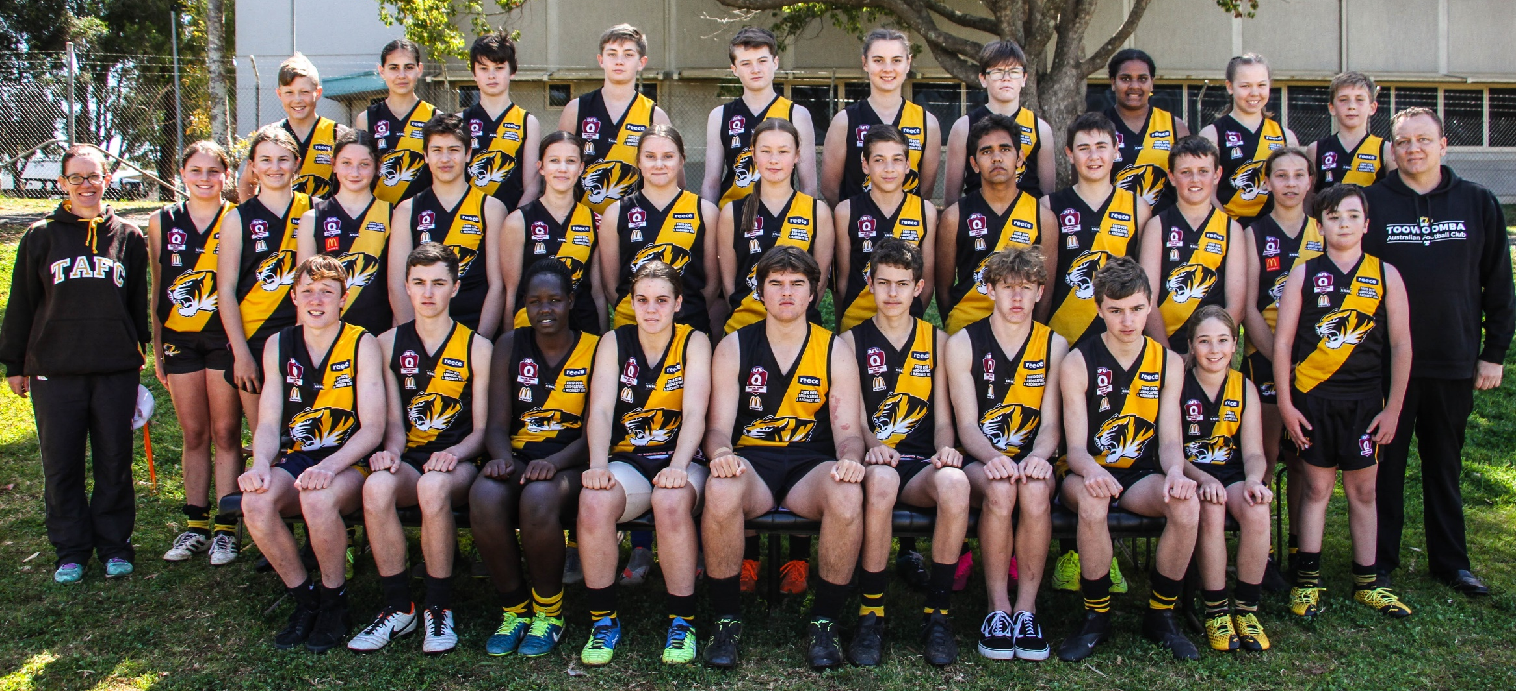

Back row L-R: Jackson Stewart, Rhianna Webb, Jack Adamson, Eli Turner, Jake Douglas-Robinson, Lara Paget, Ki Mailman, Jorja Niki,
Cheyenne Zirbel, Will Turner
Middle row L-R: Nat Fraser (Team Manager) Kathryn Elliott, Penelope Bruce, Kalea Anderson, Cooper Erdmann, Talia McEwan,
Jessica Grutt, Hayley Simmons, Jacob Bell, Keenan Williams-Burns, Mikael Artavilla-Bennett, Riley Becker,
Sienna Wilson, Aiden Diprose, Nate Miller (Coach)
Front row L-R: Oscar Kelly, Oliver Bruce, Adok Angui, Lauren Fraser (Co-Captain), Fletcher Russell (Co-Captain), Corbin Sweeney,
Lucas Paynter, Caleb Bruce, Taylor Diprose

Absent: Dan Fraser (Team Manager)

